Inclusive School Practices Toolkit
Disability Microaggressions in Education
This tool has been developed as part of the Inclusive School Communities Project, funded by the National Disability Insurance Agency. The project is led by JFA Purple Orange.

Introduction
This tool assists educators to create a safe, cohesive, inclusive school culture by supporting educators to identify microaggressions and counteract these through proactive strategies. This tool can be implemented to support a social and emotional learning program or anti-bullying program in your school. The two handouts within this tool can form the basis of professional learning.
Microaggressions, a term coined in 1970 by Chester Pierce in relation to racism, refers to remarks that are more than insensitive comments or insults. Rather, they are statements, questions, or actions that are painful and demeaning because they are directly connected to pervasive, institutionalised biases against people with devalued identities; in this case, negative disability stereotypes. Microaggressions are disconcerting as they happen casually and often without any harm intended as they are usually outside the perpetrator’s awareness of their own bias. The exact words or actions by themselves may not be offensive, but their underlying meaning reveals implicit prejudice toward students with disability.

Ideas
Why are Microaggressions Harmful?
Alarmingly, students with disability or their families often have to prove that microaggressions are offensive in the first place. Reports of micro-aggressions are considered to be subjective, where the perpetrator is considered to have ‘good intent’. Complainants may be labelled as ‘sensitive’, or part of a ‘victimhood culture’ or even accused of using political correctness to infringe on free speech. These responses are dismissive of the pain caused by micro-aggressions. Therefore, microaggressions differ from overt discriminatory remarks, which are conscious and intentional but are usually easier to manage. The ambiguity of microaggressions can result in students with disability attributing discriminatory behaviour to themselves rather than labelling it as discrimination.
What is the Effect of Microaggressions on Students with Disability?
Microaggressions are perpetrated by staff and students with adverse effects on students with disability. Even though harm is often not intended, microaggressions must be addressed for a positive, inclusive school culture to flourish.
Microaggressions are defined by the impact, not the intent. They can have long-lasting adverse effects for those on the receiving end, including low self-esteem, anxiety, depression and mental health problems. The cumulative impact of microaggressions is described by the metaphor 'death by a thousand cuts'. Other analogies include ‘shrapnel’ and ‘toxic raindrops’. Another comparison for microaggressions is having your toes stepped on inadvertently. When this happens occasionally, it is easy to move on and forget, but if this occurs daily, the pain cannot be ignored. If we tell students with disability that the perpetrator has good intent, it absolves the perpetrator from any responsibility and silences the student by dismissing their pain. It also implies it is up to the student to overcome the discrimination rather than examining the role of the perpetrator in making the student feel unsafe. Minimising the effect of microaggressions is an act of microaggression in itself. Schools need to be places where all students feel safe.
The Iceberg Analogy
Jonathon Kanter uses the analogy of an iceberg to describe micro-aggressions. The tip of the iceberg is overt discrimination, which is visible and unmistakable. Overt discrimination can usually be addressed through legal processes, that is, through the Disability Standards of Education (2005). Micro-aggressions are the harder-to-see biases that wait under the surface, more common than overt discrimination, but less detectable. These are much harder to address through the legal processes, as they are subjective. The sea the iceberg floats in is the bias enabled by society and schools. Overt discrimination and microaggressions both cause trauma for students with disability, yet microaggressions have the potential to cause more harm, as students can feel powerless and overwhelmed. Often students who experience microaggressions are caught in a double bind, if they do nothing they experience a loss of self-integrity, but raising the issue can result in unintended consequences such as not being believed.

Handout 1: The Iceberg Analogy
The iceberg analogy describes visible components of overt discrimination and the largely invisible microaggressions underneath. The key points to keep in mind are:
- This iceberg is a visual representation of the underlying structures (microaggressions) that generate discrimination against students with disability.
- The tip of the iceberg symbolises visible behaviours, that fall into the category of overt discrimination. These are obvious and easily detected.
- Underneath the iceberg, the smaller, invisible microaggressions are listed. Unlike the visible behaviours of overt discrimination, microaggressions are subtle and are explored in further depth in Handout 2.
- When educators are aware of the negative aspects of school culture that work against the inclusion of students with disability, they can implement proactive strategies for change.

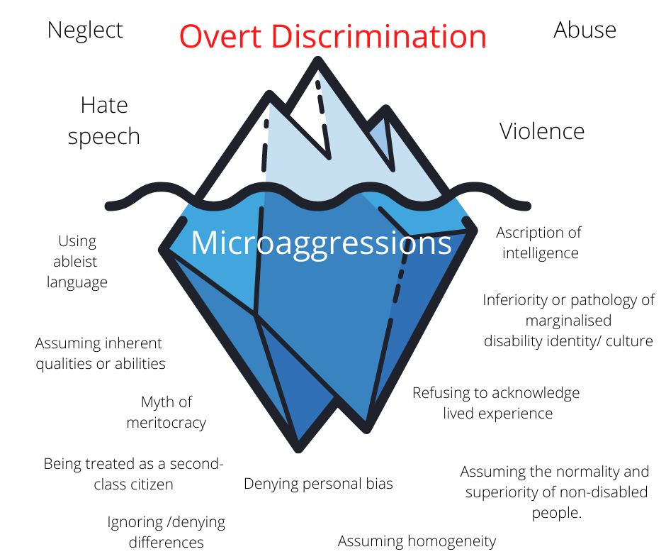
Figure 1: The Iceberg Analogy
Source: Author’s own
Picture of an iceberg with a line separating the smaller, visible part of the iceberg from the bottom of the iceberg that sits below the sea. The top is labelled as ‘Overt Discrimination’ and the words ‘neglect’, ‘abuse’, ‘violence’ and ‘hate speech’ are beside it. The bottom is labelled as ‘Micro-aggressions’ and lists ‘Using ableist language’, ‘Assuming inherent qualities or abilities’, ‘Myth of meritocracy’, ‘Being treated as a second-class citizen’, ‘Ignoring/denying differences’, ‘Denying personal bias’, ‘Assuming homogeneity’, ‘Assuming the normality and superiority of non-disabled people’, ‘Refusing to acknowledge lived experience’, ‘Inferiority or pathology of marginalised disability identity/ culture’ and ‘Ascription of intelligence.’
Actions
What Causes Microaggressions?
Ableness is a valued social norm in our society, thus creating an implicit bias against disability. Implicit bias is often unrecognised against students with disability as perpetrators claim they are acting with the best of intentions. However, social conditioning largely determines how we view certain groups, and how some, such as students with disability, are viewed in negative ways. We are subtly taught to distrust, fear, and claim superiority over people with disability. When the role of social conditioning is acknowledged in devaluing of students with disability, it can begin to be addressed. The first step is to define the microaggression, understand how this may present, as well as knowing what the underlying message is. When microaggressions are examined, strategies can be implemented to counter the negative impact. However, doing nothing will allow the status quo to continue.
- How can Educators Address this?
The table below on micro-aggressions can assist educators to develop a teaching/ learning plan to address this issue and ensure that the school is inclusive for all students, including students with disability. This table reduces an extremely complex issue to a simplistic one, but it is starting point. The table contains terms utilised within disability studies that readers may not be familiar with including:
Ableism: Beliefs that devalue and discriminate against people with disability.
Reverse ableism: Believing that people with disability receive advantages, entitlements or special treatment that oppress those without disability.
Privilege: Having an unearned benefit or advantage in society due to your identity (in this case, ableness).
The following handout, arranged as a table of information (Handout 2), may be used in individual (e.g., staff supervision and professional development meetings) or group settings (e.g., staff meeting, professional learning sessions). However a capable facilitator is required to create an environment in which participants feel safe to participate in reflection and discussion. It can be used as the basis for an exploration with staff (and students and families) about the existence of microagressions at their school. The right column of the table (strategies) is purposely designed with check boxes so readers can mark the strategies that are active and identify those that need to be prioritised and actioned.

Handout 2: A Summary of Disability Microaggressions in Schools
Define | Examples | Underlying Message | Strategies
Ascription of intelligence:  - Making assumptions about a student’s intellectual ability, competencies and capabilities.  Assuming that expressive language is indicative of understanding.  - Assuming that students with a physical disability must also have an intellectual disability. | - Speaking slowly and loudly to a student with disability.  - Speaking in a sing, song voice to a student with disability.  - Speaking to the assistant or teacher about the student, rather than to the student.  - Setting low standards without consultation.  - Substituting life skills for academic skills without consultation. | - Students with disability lack capacity. | - Treat all students with the presumption of competence.  - Reflect on the choice of language and attitude toward students with disability.  Take the time to learn about disability rights and disability perspectives.  - Empower students with disability and their families.
Assuming homogeneity:  - Assuming that all students with a particular diagnosis are alike.  - Not viewing students as individuals.  - Choosing adjustments on a student’s disability diagnosis rather than their individual needs. | - Assuming all students with disability require a life-skills program rather than an academic program.  - Using the terms ‘this’ or ‘these’ to refer to students with disability. | - Students with disability are alike. | - Approach students with disability as unique individuals.  - Engage in extensive conversations with students with disability and include their points of view into the school structure.  - Listen to students and integrate their ideas and perspectives into their individual education plan.
Assuming inherent abilities or qualities based on disability category:  - Generalisations, both positive and negative, overlook the individual and lead to inappropriate expectations.  - Students with disability and their families bear the stigma of disability. | - Assuming autistic students are males with savant skills who like trains and lack empathy.  - Assuming all students with Down Syndrome are happy and compliant.  - Assuming that parents (often the mother) of children with disability are somehow responsible for causing their child’s disability. | - The individuality of students with disability does not matter as their needs are based on stereotypes or a diagnostic label. | - Avoid stereotypes by learning about your students as individuals.  - Use strengths-based practices where you focus on what students can do, rather than what they can’t do.  - Respect and value parents and welcome their involvement in their child’s education.
Using ableist language:  - Using language that is derogatory, abusive or negative about disability, often without the intention of doing harm.  - Expecting students with disability to educate others about disability.  - Tone policing- making assumptions about intent, aggressiveness or rudeness into neutral statements. Reading a subtext that does not exist into conversations or messages. | - Using disability as an insult or euphemism e.g. ‘You’re so OCD about being on time.’  - Not allowing/ respecting students and their families to choose their own self-identifying language (e.g. insisting on saying ‘student with autism’ rather than the student’s preferred language of ‘autistic student’.  - Choosing books that contain ableist language (e.g. The popular text Wonder by R.J. Palacio uses the word ‘retard’) without providing time or space within the curriculum to reflect and challenge this choice of language. | - Disability is seen as a deficit, dysfunction or limitation, which needs to be fixed. | - Listen to the preferred language of the student and their family.  - Familiarise yourself with the preferred language of the disability community  - Be aware of pejorative language and that some terminology commonly used in schools can be problematic in the move to inclusion (e.g. the term ‘special’ is seen by many as a synonym for segregation and exclusion).  - Reflect upon biases that stem from social conditioning.  - Wherever possible, attend professional development facilitated by people with disability.
Inferiority or pathology of marginalised identity/ culture:  - Implying that students with disability are abnormal/ inferior.  - Expecting students with disability to adopt and understand the communication standard of the dominant culture.  - Claiming that special educators are ‘wonderful’ because they choose to teach students with disability. | - Assuming that students with disability will never participate in age appropriate activities e.g. have intimate relationships and therefore do not need to participate in ‘Relationships and Sexual Education’.  - Believing it is tragic that students have a disability.  - Being surprised when students succeed or do well. | - Students with disability are not acceptable or as good as people without disability. | - Focus on what students can do, not what they can’t do.  - Ensure students with disability have the same opportunities as other students within the school.  - Introduce and regularly expose the staff to positive representations of disability, preferably through teachers and assistants with disability.
Assuming the normality and superiority of being without a disability.  - Children with disability should not look visibly different from their peers.  - Students with disability must conform to the dominant cultural norms.  - Judging the behaviour of students with disability on non-disabled terms. | - Insisting that students behave in neurotypical ways such as making eye contact, not stimming, using oral forms of communication over sign language.  - Being offended when students with disability attempt to address breaches of human rights.  - Insisting that students with disability be controlled and polite at all times, despite neurological differences that make this challenging. | - People from the dominant cultural norm feel uncomfortable when spending time with those who are different from them. | - Create an environment where students with disability are respected for who they are.  - Teach students with disability to be proud of who they are.  - Expose students to positive role models with disability.  - Welcome and support the employment of teachers/ assistants with disability.
Second class citizen:  - Viewing students with disability as less worthy, less important, less deserving and inferior.  - Focusing on the disability rather than the abilities and functional needs of students. | - Not including students with disability in class photos or yearbooks.  - Giving students with disability old equipment or technology in the school, while other students have new equipment or technology.  - Assuming that students with disability could never have leadership positions in the school. | - Students with disability are less important than their non-disabled peers. | - Provide students with disability a voice.  - Ensure that students are considered to be full members of the class.  - Ensure that all students with disability are included in events within the school and beyond the classroom.  - Remind teachers/ assistants that inclusion is a legal responsibility.  - Critically reflect on the representation of disability within the school (are students with disability represented in a positive way within literature etc?)  - Encourage teachers and assistants to be open about their disabilities.
Myth of meritocracy  - Assuming that students with disability can make progress if they try harder in the absence of appropriate support.  - If students are disadvantaged by their disability, the student should change, not the environment.  - Failing to acknowledge the power dynamics between students with disability and those who do not have a disability. | - Misusing pedagogical approaches such as ‘growth mindset’ by assuming that students will succeed through more effort, even in the absence of environmental and attitudinal change.  - Using ‘inspirational’ memes, graphics or posts to show students with disability they can succeed if they try harder.  - Referring students to ‘special schools’ or ‘special classes’ as your classroom/ school is for non-disabled students.  - Claiming that students with disability receive unfair advantages because of their disability. | - All students should be treated the same by expecting them to adjust to the standardised requirements of schools regardless of their needs. | - Provide specialised intervention into classrooms rather than withdrawing and segregating students with disability.  - Facilitate accessibility through Universal Design for Learning (UDL), differentiation and Quality Differentiated Practice to proactively plan to remove barriers for diverse students.  - Utilise growth mindset with appropriate supports.  - Utilise inclusive language and avoid the term ‘special’.  - Avoid the use of inspirational memes and graphics.
Denying personal bias  - Unwillingness to admit that we all experience social conditioning that can lead to individual prejudice and discriminatory behaviour.  - The ultimate denial is the denial that non-disabled people benefit from ableism and the denial to take personal responsibility for my actions. | - Claiming that you or your school would never discriminate against a student with disability, rather than acknowledging that we live in an imperfect world where discrimination occurs.  - Refusing to be open to different viewpoints and perspectives.  - Believing that because a family member or friend has a disability, you are immune to ableism.  - Becoming defensive when it is suggested that you are biased. | - Only overt ableism is problematic. I am a good person with good intent so this is not discrimination. | - Participate in reflective practice to check for discrimination.  - Acknowledge that good intentions can harm students with disability.  - Listen to the disability community and apologise when you have harmed others and seek to inform yourself about how to approach the situation more sensitively.  - Be willing to implement change rather than placing the onus of responsibility onto students with disability to make changes.
Ignoring / Denying Differences  - Unwillingness to acknowledge or admit to seeing a student’s disability identity.  - Invalidating the experiences of students with disability.  - The denial of difference is also a denial of the power and privilege of ableness and the personal benefits accrued from this.  - When difference is denied it removes the responsibility and necessity to take action against oppression. | - Saying:  ‘I don’t see your disability.’  ‘I forget you are a student with [insert disability label] because you are …popular/ capable/ intelligent etc.’  ‘You don’t look like you have ……..’  - Using euphemisms for the word ‘disability’.  - Offering other reasons for discrimination rather than acknowledging the existence of inequity.  - Claiming that supporting a student with disability will be a distraction for other students. | - If I ignore difference, then I do not need to take action.  - Disability is tragic, so the best response is to ignore that it exists.  - The student and their parents are exaggerating their needs. | - Ensure student has appropriate supports that they self-identify.  - Develop awareness of inequity and be prepared to call out discriminatory behaviour.  - Spend time with people with disability who have positive disability identities.  - Celebrate positive disability identities.
Refusing to acknowledge lived experience  - Questioning the credibility and validity of the personal experiences of students with disability.  - Unwillingness to learn from students with disability or the disability community.  - Preferring non-disabled experts in the field of disability.  - Claiming reverse ableism exists. | - Choosing to learn about disability from non-disabled people.  - Saying ‘Why is it always about disability?’  - Saying ‘In my opinion, I don’t think you are correct ….’ when a student informs you about their personal experience of disability.  - Playing the devil’s advocate and offering an alternative opinion to the student’s experience | - Students with disability do not have insight into their own disabilities. | - Listen to students with disability and those in the disability community.  - Include literature by disabled writers in your classroom.  - Provide students with disability leadership positions if possible.  - Be aware of non-disabled privilege.  - Attend professional development run by disabled people.

More Information
The bulk of the research and literature on microaggressions is applied to race, but it can be applied to any marginalized group including students with disability. Here are websites, documents and references for further reading:
Keller, R.M. & Galgay, C.E. (2010) Microaggressive Experiences of People with Disabilities in Microaggressions and Marginality: Manifestations, Dynamics and Impact New Jersey: John Wiley and Sons
https://in.nau.edu/wp-content/uploads/sites/185/2018/04/Microagressions.pdf
The Mighty is a digital community that focuses on health and disability. This is a link to the article ‘Disability Microaggressions: How to Respond’.
https://themighty.com/2019/10/disability-microaggressions-how-to-respond/
University of Washington: Centre for Teaching and Learning. This is a link to the article ‘Addressing Microaggressions in the Classroom’.
https://www.washington.edu/teaching/topics/inclusive-teaching/addressing-microaggressions-in-the-classroom/

Acknowledgement
This tool was written by Dr Leanne Longfellow, Director of Inclusive Education Planning and edited by JFA Purple Orange. Leanne presents researched based professional learning to support teachers, assistants, other professionals and parents on inclusive practice https://inclusiveeducationplanning.com.au/

Pierce, C. (1970). Offensive mechanisms. In F. B. Barbour (Ed.), The Black seventies (pp. 265–282). Boston, MA: Porter Sargent
Sue, D.W. (2010). Microaggressions in everyday life: Race, gender, and sexual orientation. Hoboken, NJ: John Wiley & Sons, Inc.
Wong-Padoongpatt, G., Zane, N., Sumie Okazaki, & Saw, A. (2017). Decreases in Implicit Self-Esteem Explain the Racial Impact of Microaggressions Among Asian Americans. Journal of Counseling Psychology, 64(5), 574–583.
Maycock, E. (2016). Gender Shrapnel in the Academic Workplace. New York: Palgrave Macmillan
Suárez-Orozco, C., Casanova, S., Martin, M., Katsiaficas, D., Cuellar, V., Smith, N. A., & Dias, S. I. (2015). Toxic Rain in Class: Classroom Interpersonal Microaggressions. Educational Researcher, 44(3), 151-160.
Kanter, J. W., Williams, M.T., Kuczynski, A.M., et al. (2017). A Preliminary Report on the Relationship between Microaggressions against Black People and Racism among White College Students. Race and Social Problems, 9, 291–299. https://doi.org/10.1007/s12552-017-9214-0

