Inclusive School Practices Toolkit
Maximizing the Success of Service Providers working with Students in School
This tool has been developed as part of the Inclusive School Communities Project, funded by the National Disability Insurance Agency. The project is led by JFA Purple Orange.

Introduction
The introduction of the National Disability Insurance Scheme (NDIS) along with the Chronic Disease Management (formerly Enhanced Primary Care or EPC) and Better Access to Psychiatrists, Psychologists and General Practitioners through the MBS (Better Access) initiatives has meant more allied health professionals are working with students in schools. While some schools have opted not to allow service providers like occupational and speech therapists to engage with students on school grounds during school time, other schools (especially those in rural and regional areas) have needed to welcome, coordinate and facilitate a range of therapists to work with their students. These schools are increasingly needing to work with service providers and establish school policies and procedures around this that set up communication and collaboration between students engaging with therapists at school, their parents/caregivers, school staff, and therapists/service providers.
Schools are seeking guidance on how best to communicate and collaborate with therapists/service providers to support that student’s participation and engagement at school and their overall learning and development. This tool outlines some benefits of students engaging with therapists in school. A summary of the advantages of collaboration between schools and therapists/service providers is provided as well as the six critical elements for collaboration.
Horizon Christian School is a Foundation to Year 12, co-educational Christian School situated in the rural township of Balaklava, South Australia. They have a large student population with students travelling long distances from surrounding rural townships. Due to their location and the various barriers for their students to access therapies, Horizon Christian School welcomes and supports service providers to engage with their students on site during school hours. They have developed an approach to working with service providers based on communication and collaboration. This tool is based on their experience of working collaboratively with a range of different services providing therapy to their students.

Ideas

Benefits of Therapists/Service Providers Engaging with Students in School
Therapy within the school setting reduces the time students spend away from school to attend therapy appointments. In a rural or regional area with limited service providers, students will need to travel outside of the area to reach service providers and they may miss a whole day of school; this causes disruption to school routines and can affect academic and social outcomes. This also requires parents/caregivers to take time away from work and other activities to transport their child to appointments, which is often not feasible on a regular basis. When therapy is delivered within the school setting, it becomes normalized and part of everyday activities enabling students to engage with therapists/service providers with minimal disruption to their schooling; the student may miss out on one or two lessons as opposed to a whole day when accessing therapy off-site. Having therapists/service providers meet with students at school often means the appointments are held consistently (less cancellations due not relying on parents/caregivers), rapport and trust is built quicker between the student and therapist due to the student being in the familiar environment of their school, and the student has a good opportunity to progress in their therapy.
Therapists can also observe students in the school setting and engaging with school staff and peers; this can help to identify adjustments, supports, and resources that the school can implement to aide engagement and learning. Schools can utilize the professional expertise of therapists to improve their communication and teaching instruction to suit students’ needs, strengths and preferences. Therapists can also be involved in case management and learning plan (IEP/NEP) meetings along with the student and parent/caregiver, providing their observations and expert advice on supporting the students social and academic success at school.
Research into collaboration between teachers and speech and language therapists found the following advantages of collaboration, however these also apply with other types of therapies:
- consistency of approach
- transferring/sharing of knowledge and skills between professionals
- an approach that meets the demands of both curriculum and therapy
- ensures a holistic approach
According to this research, the best intervention ideally combines the knowledge and skills of teachers, therapists and parental insight. However there are also various benefits of including students in this process by ensuring they have choice and voice and are engaged in any collaboration involvement their parents/caregivers, school staff, and therapists.
Six critical elements to sustain a service delivery model with allied health professionals collaborating with teaching staff were identified by the Australian Government Department of Education and Training in the Evaluation of the More Support for Students with Disabilities Initiative 2012-2014:
- An end point in mind
- Support from school leadership
- Resourcing
- The skills of the allied health professional
- A spirit of collaboration
- Skilled coordination
Each element is important to build a cohesive and robust framework for collaboration between allied health professionals and school staff. Each element is summarized below, drawing on the Evaluation of the More Support for Students with Disabilities Initiative 2012-2014 and the experience of Horizon Christian College, an independent school participating in the Inclusive School Communities Project.

An End Point in Mind
The development and success of the child is always the end point. Enabling therapists to meet with students at school can be a mechanism to support students to access the curriculum and have the best outcomes. A collaborative relationship between the therapist and school staff where each party brings their expertise, opinions and ideas alongside the student and their family will support successful and sustainable outcomes for the student. Any therapy provided to students in school hours should be purposeful and clear targets or milestones should be set and reviewed regularly. Therapists can be involved in case management and learning plan meetings if it is relevent and the student and family agrees.

Support From School Leadership
If the school makes the decision to allow therapist to meet with students on site during school time, then the school principal and other leadership staff must be supportive and ensure all school staff are welcoming and supportive to therapists. The school needs a procedure in place for therapy provision on site and school leadership ensures this is followed and reviewed regularly. The school should expect therapy of the highest quality for their students; ongoing discussion with and monitoring of therapists is essential.

Resourcing
Adequate resourcing is essential to the success of collaborative relationships with therapists and the effectiveness of the therapy for students. Time is required for a staff member to coordinate the therapy sessions, book/set up rooms and equipment, and communicate with educators and other school staff who are affected. Work spaces and private rooms within schools are often limited and/or in high demand so it can be difficult to find a room that is suitable for therapy sessions. Consideration to the student and therapist is important; a corridor may not provide a space that is conducive to therapy. If the school agrees for therapy to occur on site, they must provide a suitable room that is appropriate for the type of therapy being provided but also considers the privacy and safety of the student. Therapists are generally flexible and willing to work with school staff to locate an appropriate space to use. The provision of an appropriate room for sessions conveys to the therapist, the student and their family that this time is valued and the school supports the therapy.

The Skills of the Allied Health Professional
Whilst all therapists are trained in their area of expertise, it is essential there is a good fit with the school and how the school operates. A therapist must be able to work within the school’s values and guidelines including conducting themselves in a professional manner at all times.
Therapists are usually organised by parents/caregivers. Therapists are support to engage students on site under the proviso they follow the school’s policies/procedures, are contacted initially before coming on site, and that communication between the school, parents/caregivers and therapist remain open and collaborative. Initial contact by the staff member assigned to this responsibility with the therapist will involve a discussion about the school’s ethos and expectations of outside agencies using the school’s facilities including signing in procedure, punctuality, collecting and returning students. The staff member also ensures the appropriate checks and paperwork is sighted.
Therapists may be able to offer the school strategies to support the student at school; academically, socially and emotionally.

A Spirit of Collaboration
For collaboration to be successful, everyone must be a willing listener, an active participant, and be open to new ideas to help the student’s learning and development. Collaboration supports the student’s progress in therapy as well as academically and socially at school. A successful collaborative relationship may include front office staff knowing that the therapist is coming, having a suitable space and equipment booked, staff knowing that a student is booked in for therapy and reminding the student beforehand to prepare, communication between the school, student and parent/carergiver, and therapist if there is an event or illness that will means therapy cannot occur, and regular feedback provided by the therapist either verbally or in writing (e.g., email) as appropriate to the type of therapy.

Skilled Coordination
Coordination of therapy sessions held on site during school hours is essential. The allocation of a staff member, usually from the leadership team, who is the point of contact for bookings and communication ensures procedures are followed and students including ensuring rooms are allocated and relevant educators are notified. Many therapists may come into the school each week and this will need to be successfully coordinated. Assigning this responsibility to a specific staff member and allocating enough time for these duties will ensure a high level of organization, ongoing and open communication, and ensure the best outcomes for students. Scheduling, communication channels, and implementing recommendations need to be agreed upon upfront between the school and therapist and upheld to ensure a successful, collaborative relationship. This requires accountability from all parties and clarity around expectations. Communication via email and phone, face-to-face discussions, and school case meetings with the therapist will need to occur as necessary.

Action
Due to their location and the various barriers for their students to access therapies, Horizon Christian School welcomes and supports service providers to engage with their students on site during school hours. They have developed a clear procedure for engaging with and supporting service providers based on communication and collaboration. A simplified version of Horizon Christian School’s procedure is outlined below as an example that you can use to review or improve your school’s approach.

Initial Contact is Made by the Provider
- Email the provider an initial letter. (Appendix 1)
- Email the provider a booking form (Appendix 2)

Upon Return of the Booking Form
- Book a space for the provider on a central data base such as Google Calendar (Appendix 3). This allows office staff to be aware of the visit and offers a welcoming start. This information is also linked to the Staff Day Books and other communications channels.
- Collate information and email teachers with existing bookings (Appendix 4). This occurs at the end of the week for the following week.
- After a few sessions, gather feedback from educators and front office staff including about whether the scheduled time is working. If needed, work with the therapist to find a more suitable time that minimizes disruption to the student’s timetable e.g., If a student will miss out on a specialist subject regularly can an alternative time be found. Changes to scheduling are kept to a minimum for ease of the student, therapist and school. The ripple effect of changes in scheduling can be large in a school. Changes are then emailed to the relevant teachers.
- Any clashes that arise due to school camps or excursions are emailed to the therapist with as much notice as possible.
- When therapist arrive on site and sign in, they are shown where the bathrooms and refreshments are located and directed to their allocated space.
Horizon Christian School has provided their initial provider letter/email, booking sheet, Google Calendar room booking example, and therapy booking information for class teachers in the appendix.

Therapy with Students Outside of School
If therapy occurs outside of the school setting, the school can still initiate and maintain successful communication and collaboration with a service provider who is working with their student. This is always done in the best interests of the student and in support of their social and academic success at school. With permission from the student and parent/caregiver, the school can engage the service provider through the following actions:
- an introductory email that expresses willingness to work together
- regular emails sharing school observations, strategies that are working, and any areas of concern
- offer to discuss their recommendations, observations and concerns
Depending on the student and other factors and if this is agreed upon, parents/caregivers may be included in email correspondence between the school and the therapists to enable open sharing of information and good communication.

Appendix
Appendix 1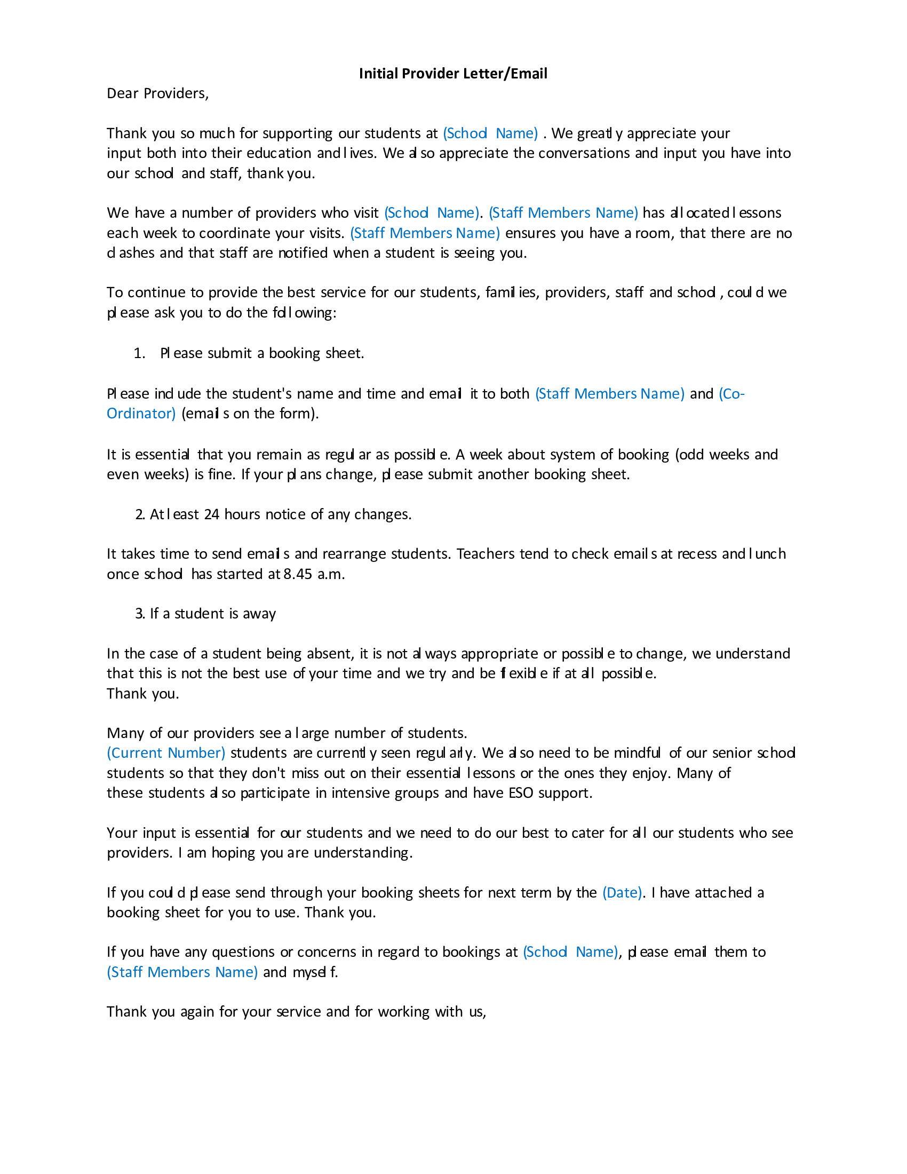

Appendix 2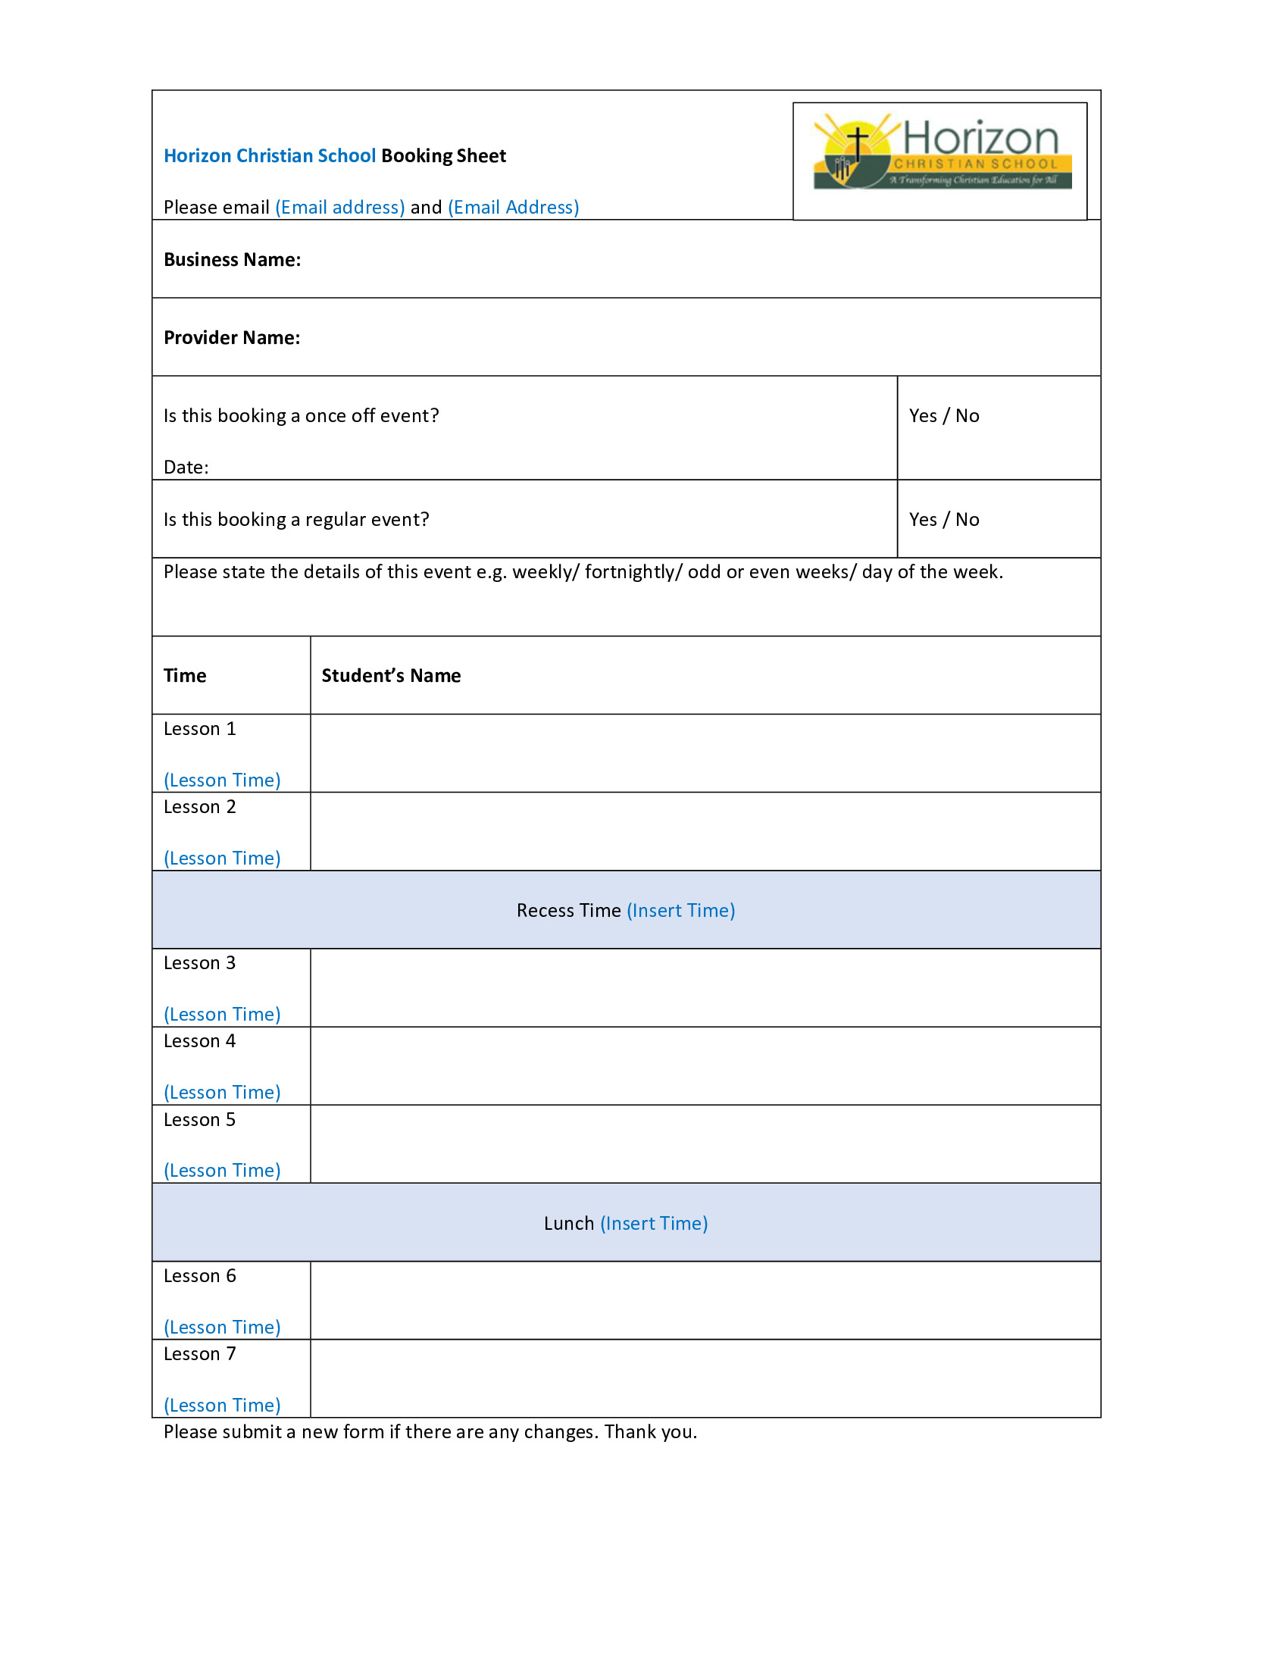

Appendix 3
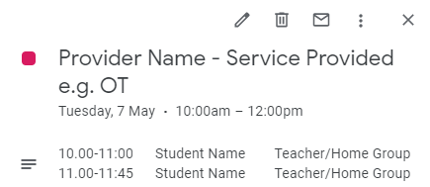

Appendix 4
YEAR LEVEL – TEACHER NAME
Week
Name | Day/Time | Occurrence  Weekly/Fortnightly | Provider
Student Name | Monday  9.00-9.45 | Fortnightly  Even Weeks | Provider Name  Service Provided
Student Name | Tuesday  11.30-12.30 | Selected Dates | Provider Name  Service Provided

More Information
Article in the Child Language Teaching and Therapy (journal) on ‘Collaboration between teachers and speech and language therapists: Services for primary school children with speech, language and communication needs.’ https://doi.org/10.1177/0265659015603779
Final Evaluation Report for the Evaluation of the More Support for Students with Disabilities Initiative 2012-2014 published by the Australian Government Department of Education and Training. https://qed.qld.gov.au/det-publications/reports/Documents/evaluation/evaluation-support-students-disabilities-initiative.pdf

Acknowledgement
This tool was written by Julie Lawson, Student Learning and Engagement Coordinator and Lisa Veitch, Education Support Officer at Horizon Christian School with editing by JFA Purple Orange.

Glover, A., McCormack, J., Smith-Tamaray, M. (2015). Collaboration between teachers and speech and language therapists: Services for primay school children with speech, language and communication needs. Child Language Teaching and Therapy, 31(3), 363-382. https://doi.org/10.1177/0265659015603779
Ibid.
PhillipsKPA (2015). Evaluation of the More Support for Students with Disabilities Initiative 2012-2014 – Final Evaluation Report. Australian Government Department of Education and Training. Retrieved from https://qed.qld.gov.au/det-publications/reports/Documents/evaluation/evaluation-support-students-disabilities-initiative.pdf
Ibid.

