Inclusive School Practices Toolkit
Appreciative Inquiry Tool 1: Introduction to Appreciative Inquiry for Schools
This tool has been developed as part of the Inclusive School Communities Project, funded by the National Disability Insurance Agency. The project is led by JFA Purple Orange.

Introduction
This tool is the first in a series of three, written by Dr Katy Osborne who is a social scientist with a background in psychology and public health, currently working as a Research Fellow at the Southgate Institute for Health, Society and Equity.
Appreciative inquiry (AI) is a strengths-based, collaborative approach to organizational change which focuses on understanding the ‘positive core’ of an organization and how this can be strengthened. It has been aligned with the field of positive psychology, due to a shared focus on strengths and positive functioning. AI is well suited as an approach to guide empowering change in schools and has been used to guide change across different school settings.
This tool provides an introduction to AI including the principles and cycle. School leaders may use AI as an approach to manage change with inclusive school development.

Ideas

What is Appreciative Inquiry?
The following practice-based definition is provided by the co-founder of AI, David Cooperider, and a leading AI practitioner, Diana Whitney:
Appreciative Inquiry is the cooperative, co-evolutionary search for the best in people, their organizations and communities, and the world around them. It involves systematic discovery of what gives “life” to an organization or community when it is most effective, and most capable in economic, ecological, and human terms. AI assumes that every organization or community has many “untapped and rich accounts of the positive” – what people talk about as past, present and future capacities – the positive core. AI links the knowledge and energy of this core directly to an organization or community’s change agenda and changes never thought possible are suddenly and democratically mobilized. (p. 276-277)
AI can transform a school’s culture, change student outcomes and fix broken processes; all with the school leadership team, teachers, students, and community holding the power.

How is Appreciative Inquiry Relevant for Schools?
As a strengths-based approach to organisational change, AI has been viewed as important in the field of positive education and valuable for promoting schools as ‘positive institutions’. It has been argued that, for schools particularly, the positive approach of AI offers a more valuable starting point for change than a deficit-based approach, which can lead to distrust and a lack of commitment from school stakeholders. AI has been used to guide change across different school settings. For example:
- Planning for groups of schools in specific geographic regions
- Strengthening partnerships between schools, local communities and other public institutions
- A tool for positive change within individual schools
These examples are explored further in Appreciative Inquiry Tool 2: Application of Appreciative Inquiry to Support Organisational Change in Schools. AI is an approach that schools can use to develop inclusive school communities and practices.

How Does Appreciative Inquiry View Organisational Problems?
Organisational change seeks to bring about improvement, and as part of identifying what needs to be improve, it is often viewed as necessary to identify existing problems. Therefore, it is worth considering how AI views existing weaknesses or deficits. AI does not ignore problems that may exist within organisations. However, according to AI, positive change is more likely to occur from focusing on strengths. Problems are not used as a basis for action. It is important to listen to problems that have occurred and validate them. AI then seeks to re-frame problems to identify what may have worked well in responding to or coping with negative events and uses these positive insights as a basis for further action.
Handout 1: Principles of Appreciative Inquiry
AI is underpinned by five core principles as displayed below.
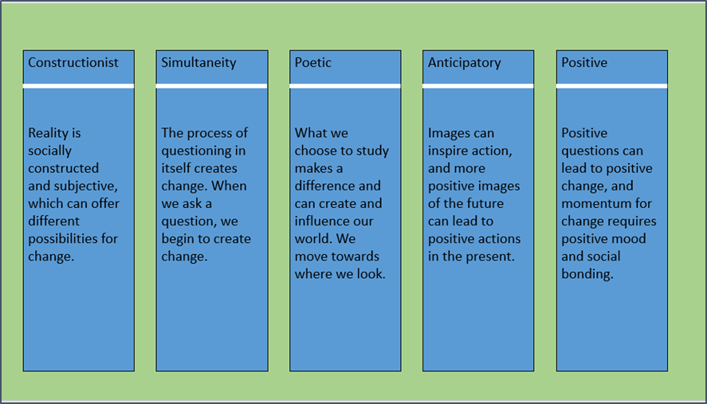

Cooperider, D., & Whitney, D. (2006). Appreciative inquiry: A positive revolution in change. In The Change Handbook (pp. 275–289). San Francisco, CA: Berret-Kohler Publishers.

Handout 2: The Appreciative Inquiry Process and the ‘5D’ cycle
The AI process follows the 5D cycle as displayed below.
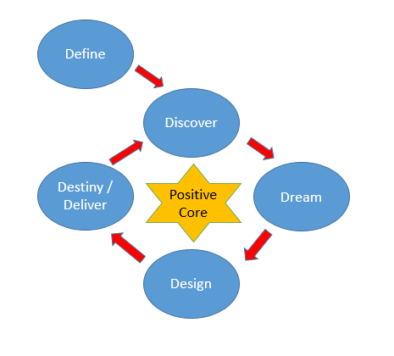

Each of the steps in the 5D cycle is described below:
- Define: What is the focus of inquiry?
It is important to clarify the topic and overall focus of inquiry. As a starting point, this defines the project’s purpose and what needs to be achieved. This is the recently added fifth step which transformed the ‘4D’ to the ‘5D’ cycle.
- Discover: What are our strengths?
This step involves asking questions to identify existing strengths and positive processes already in place. This can be understood as the organisation’s ‘positive core’. It is important to let go of a desire to diagnose weaknesses. Rather, the focus is on examples of ‘organisational excellence’ and what factors have made these possible.
- Dream: What is possible in the future?
Once an organisation has discovered its strengths, the next phase focuses on envisioning what could be possible in the future. This involves thinking about ‘great possibilities’ for the organisation. Importantly, these possibilities should be grounded in the positive examples of what the organisation has already achieved.
- Design: How do we get there?
This phase focuses on creating the ideal organisation in order to achieve the possibilities identified in the Dream phase. There is a focus here on participants co-constructing positive, sustainable change for the organisation that builds on existing strengths and past successes.
- Destiny/Deliver: How do we stay committed?
This phase represents the conclusion of the previous phases and an ongoing commitment to building an appreciative learning culture in the organisation. During this phase, the momentum for positive change is sustained by continuous learning. Participants identify what they can do to contribute, in an ongoing way, to the realisation of the organisational dream

Actions
An understanding of AI as an approach to guide empowering change in schools is helpful for school leaders. Handout 1 on page 3 of this tool summarises the five core principles of AI. The AI process for organisational change has traditionally been undertaken in four steps, with the recent addition of a fifth. This process is commonly referred to as the ‘4D cycle’ or ‘5D’ cycle. These steps refer to Define (the most recent step), Discover, Dream, Design and Destiny. Handout 2 on page 4-5 of this tool describes the 5D cycle of AI. Handout 2 may be used as a starting point for conducting an AI process according to the 5D cycle:
- Define: What is the focus of inquiry?
- Discover: What are our strengths?
- Dream: What is possible in the future?
- Design: How do we get there?
- Destiny/Deliver: How do we stay committed?
AI is a researched and documented approach for change that has been successfully used by schools to transform their culture and cope in periods of tension, stress and change. Schools can use AI as an approach to inclusive school development, starting from “what people talk about as past, present and future capacities – the positive core”.

More Information
Appreciative Inquiry has its origins in a 1987 article ‘Appreciative inquiry in organizational life’ by Cooperrider and Srivastva https://www.centerforappreciativeinquiry.net/wp-content/uploads/2012/05/APPRECIATIVE_INQUIRY_IN_Orgnizational_life.pdf
Appreciative Schools website containing articles and videos on AI in schools by the author of ‘Transformational Leadership’, Dr. Richard K. Nongard http://appreciativeschools.com/
Free toolkit, Appreciative Inquiry starter’s guide https://www.michellemcquaid.com/toolkit-ai/?utm_source=website&utm_medium=home-page

‘The Appreciative Inquiry Summit’, a resource book for practitioners leading large-scale change, written by the Center for Appreciative Inquiry’s, Dr. Jim Ludema with Diane Whitney.
‘The Power of Appreciative Inquiry’, an introductory book by Diane Whitney and Amanda Trosten-Bloom.

Acknowledgement
This tool was written by Dr Katy Osborne, Consultant and edited by JFA Purple Orange.

Waters, L., & White, M. (2015). Case study of a school wellbeing initiative: Using appreciative inquiry to support positive change. International Journal of Wellbeing, 5(1), 19–32.
Filleul, M., & Rowland, B. (2006). Using appreciative inquiry in the Vancover school district: A positive approach to enhance learning. BC Educational Leadership Research; San Martin, T. L., & Calabrese, R. L. (2011). Empowering at-risk students through appreciative inquiry. The International Journal of Educational Management, 25(2), 110–123. https://doi.org/10.1108/09513541111107542; Waters, L., & White, M. (2015). Case study of a school wellbeing initiative: Using appreciative inquiry to support positive change. International Journal of Wellbeing, 5(1), 19–32.
Cooperider, D., & Whitney, D. (2006). Appreciative inquiry: A positive revolution in change. In The Change Handbook (pp. 275–289). San Francisco, CA: Berret-Kohler Publishers.
Nongard, R. K. (n.d.). Appreciative inquiry initiatives. Retrieved from http://appreciativeschools.com/
Waters, L., & White, M. (2015). Case study of a school wellbeing initiative: Using appreciative inquiry to support positive change. International Journal of Wellbeing, 5(1), 19–32.
Bergmark, U., & Kostenius, C. (2018). Appreciative student voice model – reflecting on an appreciative inquiry research method for facilitating student voice processes. Reflective Practice, 19(5),623-637. https://doi.org/10.1080/14623943.2018.1538954
Filleul, M., & Rowland, B. (2006). Using Appreciative inquiry in the Vancover School District: A positive approach to enhance learning. BC Educational Leadership Research.
Calabrese, R., Burkhalter, K., Hester, M., & Friesen, S. (2010). Using appreciative inquiry to create a sustainable rural school district and community. International Journal of Educational Management, 24(3), 250–265. https://doi.org/10.1108/09513541011031592
Calabrese, R., & San Martin, T. (2019). The power of an appreciative inquiry 4-D cycle in a non-AYP middle school: Positive direction for eighth-grade teachers. Retrieved from https://www2.education.uiowa.edu/archives/jrel/Calabrese_0803.htm; Waters, L., & White, M. (2015). Case study of a school wellbeing initiative: Using appreciative inquiry to support positive change. International Journal of Wellbeing, 5(1), 19–32.
Cooperider, D., & Whitney, D. (2006). Appreciative Inquiry: A Positive Revolution in Change. In The Change Handbook (pp. 275–289). San Francisco, CA: Berret-Kohler Publishers.
Cooperider, D. (2012). What is Appreciative Inquiry? Retrieved from http://www.davidcooperrider.com/ai-process/; Weatherhead School of Management, Case Western University. (n.d.). 5D cycle of Appreciative Inquiry. Retrieved from https://appreciativeinquiry.champlain.edu/learn/appreciative-inquiry-introduction/5-classic-principles-ai/
Cooperider, D., & Whitney, D. (2006). Appreciative inquiry: A positive revolution in change. In The Change Handbook (pp. 275–289). San Francisco, CA: Berret-Kohler Publishers.

