Report – School Student Consultation

Introduction

Two focus group sessions for the Inclusive School Communities Project were held with students at a South Australian secondary school in February 2020. Each session had roughly 15 participants from years 9-12 and some students participated in both sessions. Most of the participants had a diagnosed disability and/or self-identified as living with disability or an additional need. About half of participants had been in recently dismantled smaller (segregated) classes and had only recently returned to mainstream classes, whereas the other half had been in mainstream classes throughout their entire time at this school.

The focus group sessions were facilitated by two School Mentors who are young people living with disability from diverse professional backgrounds, with support from the Project Leader. All participants provided informed consent and their parents/caregivers were advised in advance about their child’s participation in the research. Participation was voluntary and no payment or reward was provided. Participants were advised at the start of each session that their responses would be given as feedback to their school and summarised in report that would be publicly available (with no student being individually identified). The focus group sessions were audio recorded and transcribed. One participant also took notes as an additional method of ensuring all comments were recorded.

The first session centered on the following questions:

1. What does ‘belonging’ mean to you at school?
2. What does your school do to help you feel included and valued?

The second session centered on the following questions:

1. What could your school do differently or better to make you feel included and valued?
2. What are the barriers or challenges for students living with disability or students who have additional learning needs at your school?

To accommodate the variety of student needs, some students left the room at times and came back when they were ready. We observed different levels of engagement and participation among the students however, particularly in the second session, all students contributed in an open, honest discussion. When analysing the transcription, it became clear that participants’ answers often did not match the questions and instead focused on three interconnected themes:

* Theme 1: Access
* Theme 2: Relationships with Peers
* Theme 3: Relationships with School Staff

This report, therefore, summarises the responses from each question under these three themes and further subthemes.

Acknowledgement

This report was written by Leeanne Marshall, an autistic young person. Leeanne holds a Master of Teaching (Special Education) (Secondary) and is currently undertaking a Master of Disability Policy and Practice. Leeanne is on the project steering group and is an Inclusive School Mentor. This tool was edited by JFA Purple Orange.

Theme 1: Access

One of the key themes revealed in the data is access and this theme is divided into three subthemes: access to the physical environment, access to school events and peers (organised by school staff), and access to curriculum (including staff assistance).

*Access to the physical environment including school facilities*

Students involved in the focus group sessions mentioned several physical access issues for students living with disability attending the school. One area of concern was access to upstairs for people with a permanent or temporary physical impairment. One student reported that an elevator was installed to provide access to upstairs *”…but* *we only have one key for it so there have been multiple people who have been injured at one time and they have all had to stay in the library or get carried up the stairs by their friends.”*

Another physical accessibility issue identified by the students was the entrance and exit to the library. The library entrance is accessible to students, but students are not allowed to exit the library that way. Instead students must use an exit that has a steep drop, making it dangerous or impractical for students with a physical injury or disability. While students with such injuries or disabilities can use the accessible entrance, sometimes teachers still force these students to use the designated library exit. Other students also sometimes exit the library through the entrance because the library gets crowded and finding the exit can sometimes be difficult.

Overall, as one student said: “*Making buildings more accessible for people who use wheelchairs and who don’t use wheelchairs*” is something the school could work on. The above examples indicate the school did implement some strategies to increase physical access but students identified problems with these strategies. Access to the physical environment of the school needs to be considered when thinking about access and inclusion.

Access to food and the type of food available from the school canteen was another concern raised, with some students mentioning specific foods they would like on the canteen menu. One student stated that the school needs to:

*“Get more stuff in the canteen – before it’s even halfway through lunch, it’s basically empty and the majority of people don’t even get food because other people buy a big bunch of food and won’t leave much for everyone else.”*

Students with mobility restrictions and other disabilities or additional needs may take more time than their peers to arrive at the canteen and may be unfairly missing out. In addition, one of the facilitators noted that students living with certain disabilities have a restricted diet, unusual eating behaviours, food allergies, etc. and their access to canteen foods needs to be considered. Solutions to address the limited quantities and variety of canteen food available and the problem of students buying more than their share need to be explored further. A final comment about physical access issues was that more spaces were needed in the school sickbay as this sometimes was at capacity forcing students to wait out in the hallway. This is important since we know that some disabilities result in weaker immune systems; therefore some students living with disability are more likely to get sick and need to access the sickbay.

Access to school events and peers

Several participants discussed school events and the inclusion of students living with disability. One participant stated that “*events like sports day, homegroup, excursions*” made students feel included. Other students disagreed, with one participant saying:

*“I can’t do things that others* [sic] *students do because of epilepsy so like other students will go do stuff and I’ll get left behind because I can’t do it. An example is on sports day other kids so some people were on the equipment and I couldn’t go on it with them and hang out with them and spend time with them because it could cause a seizure.”*

Regarding school staff and planning for sports day, one student said, *“Not necessarily changing everything they are going to do but making some differences so that other people can be included.”*

The above comments suggest that school events and activities can help students living with disability feel included at school and provide access to peers. However, this is only the case when access and inclusion for all students is considered in advance and well planned.

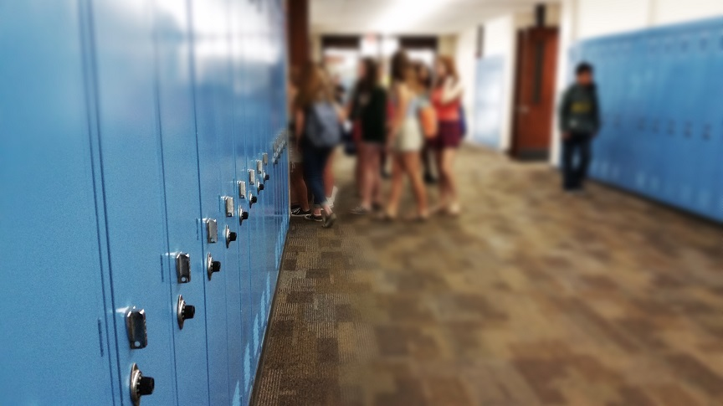

One participant reported that he still gets bullied because he had been in the ‘special’ program for students living with disability or additional needs, however he did note that *“We're all now in mainstream though and it’s dying down a little bit because everyone is used to it.”*

This indicates that returning those students to general education classrooms increased their access to peers and is beginning to improve their relationships with peers (this is discussed further under Theme 2: Relationships with Peers).

Access to curriculum including staff assistance

Students discussed the strengths and limitations of access to the curriculum including staff assistance. Students provided the following examples of how teachers help them to access the curriculum:

* allowing extensions on assignments if needed
* allowing breaks from class to recharge
* helping students understand the curriculum both during class and after school
* having School Services Officers (SSOs) (teacher aides) in the classroom for extra assistance

Students suggested that teachers are available and willing to help even students that are not in their classes. This is exemplified in the following comment:

*“….there are also other teachers you can go to – even if they aren’t your class teacher, you can still go to them – even if you can’t ask your class teacher for help on your work, you can go to other teachers that teach that subject like if its general maths, you can go to another math teacher.”*

In contrast some students felt that the support from teachers did not go far enough in subject areas such as Vocational Education and Training (VET) and Maths. These students wanted more one-on-one time with teachers and support to catch up on schoolwork in these areas. Students also discussed other things that aren’t working at their school and ideas for improving access to the curriculum.

Students raised the following issues:

* teacher unavailability during student study time
* noise in the classroom – some students reported that noise affects their concentration
* limited availability of SSOs (one per class) when so many students needed extra assistance
* large class sizes

Students raised the following solutions and ideas

* access to a quiet study space
* access to music through headphones
* smaller class sizes

Overall, the focus group sessions revealed that this school has made efforts around access to the physical environment, to school events, and to curriculum however students thought this could go further and identified several areas and ideas for improvement. These findings emphasize the importance of providing students with opportunities to provide feedback, explore school challenges, and contribute to solutions and ideas especially when it comes to addressing accessibility issues.

Theme 2: Relationships with Peers

Relationships with peers at school were discussed extensively across both focus group sessions and this theme is divided into two subthemes: attitudes, and inclusion and exclusion. There are connections between this theme and Theme 1: Access.

Attitudes

Students discussed what it is like to belong and feel included at school. They identified a few attitudes and actions that lead people to feel comfortable, safe, and happy at the school:

* Respect everyone and respect differences
* Show compassion for what classmates might be going through
* Helping fellow students when assistance is needed
* Encouraging fellow students to be nice to all students
* Giving everyone an opportunity to voice their opinion

A few comments that illustrate these examples:

*“Include everyone even if they have a disability or different culture”*

*“Even if someone is a little bit crazy in the mornings – be patient with them.”*

Students also mentioned attitudes and actions that could make people feel like they did not belong at school and there was lively conversation about name-calling, put-downs and examples of harassment and bullying in relation to sexuality, disability, adoption, other family circumstances, religion, evidence of self-harming, taste in music and appearance/body weight. As one participant said:

*“I get teased about my weight because I was anorexic.”*

Another participant stated:

*“Even our siblings get bullied because* [of] *the way we are. My sister, she’s not on the spectrum, but she gets bullied because I’m on the spectrum and she has to usually come in and help me but because she has to deal with this stuff and she gets looked at people differently.”*

The responses suggest that more understanding and acceptance of diversity is needed for these students to feel included. There are various practices and strategies that schools can implement to ensure their students, as well as staff, feel a sense of belonging to the school community.

Inclusion/exclusion by peers

Some participants highlighted examples of students living with disability being excluded in peer-led activities. One comment was:

*“Some students that have disabilities get excluded from activities so like if students are playing, they won’t play with the students who have disabilities because they are not good enough or something or they won’t know what to do – it has happened to a couple of people that I know.”*

An example was offered of a student living with disability not being allowed to play basketball because the students without disability would not let him. No solutions for this were raised at the focus group but it is an issue that this school and other schools are encouraged to consider when thinking about inclusion for all students.

Bullying was frequently cited during both sessions as a problem with peer relationships. Students reported that the perpetrators of bullying are sometimes suspended and the location of internal suspensions can be problematic such as when it is a common area like the library. Some students reported feeling uncomfortable or even avoiding certain areas when specific students were undergoing internal suspension. As such, participants felt excluded from some areas of the school.

None of the participants shared examples of peer-led inclusion currently operating at the school however, students had various ideas and were keen to implement peer-led inclusion activities. These ideas focused on older students having responsibility for this and leading by example. One participant suggested:

*“…if it’s a younger class, maybe like the older students can go and help with them – it also gives them more responsibility so like it shows them what it’s like to help others, look after them, that sort of stuff – it’s not just the captains doing the work, it’s everyone else.”*

This recommendation was not just to assist with peer relationships but also to assist younger student with academic success. Other participants advocated for older students or the Student Representative Council (SRC) to assist younger students on school camps. In this way, the older students/SRC act like role models for the other students. If the younger students see the older students helping/socialising with students living with disability, they might do the same.

Another participant thought school staff could assist with peer inclusion by mixing up year level classes. This student gave an example of the school going from year 8/9 classes to year 8/9/10 classes. This would give students an opportunity to socialise with different peers.

It was evident from the focus group sessions that students living with disability had experienced bullying and exclusion by their peers with and without disability. This school, and other schools working towards inclusion, are encouraged to explore the ideas for peer-led inclusion proposed by the students in these focus group sessions. Interestingly, peer-led activities such as peer tutoring and peer mentoring are considered effective and essential practices in inclusive schools.

Connection to theme 1

Clearly, Theme 1: Access and Theme 2: Relationships with Peers are heavily connected. To foster positive relationships between students living with disability and their peers, the students living with disability need to be able to access the same buildings, classes, and activities as other students.

Theme 3: Relationships with School Staff

The third theme raised by students was relationships with school staff and this theme is divided into two subthemes: attitudes of students and school staff towards each other, and availability of school staff for support. Some points in this theme are relevant to and already raised in Theme 1: Access and Theme 2: Relationships with Peers.

Attitudes of students and school staff towards each other

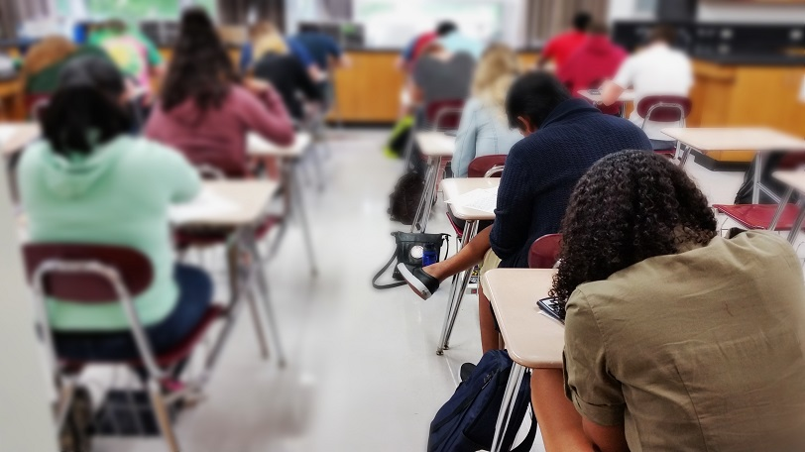Several students mentioned that respect between teachers and students was important. This referred to both teachers respecting the students and the students respecting the teachers. This is an acknowledgement that a lack of respect on either side could cause issues. Students shared positive feedback about school staff recognising *“They don’t treat us like children, they treat us like individuals – like adults, like people.”* Their responses also indicated staff are honest and good communicators and recognise students needed to be treated differently, treated as adolescents, and told relevant information.

On the other hand, one student commented that the staff lacked:

*“Understanding that we are not the same – they sometimes treat us like we are the same as the other kids even though we’re not and they don’t understand what our needs are.”*

Similarly, another student mentioned that a maths teacher did not understand the needs of some of the students living with disability in a maths class. This indicates that some staff at the school do not have the attitude that some students need to be treated differently to succeed at school.

Relating to students being treated differently, there were inconsistencies at the school regarding practices such as students taking a break from class (as mentioned in Theme 1). Some teachers allowed this, other teachers allowed it under limited circumstances (e.g., a time limit), and others did not allow it at all. This illustrates the importance of consistency and school-wide practices to ensure the needs and preferences of students are accommodated.

Availability of school staff for support

Availability of school staff for curriculum support is discussed in Theme 1: Access. However, students in the focus group sessions raised other strengths and weaknesses regarding availability of school staff for support, which are relevant to this theme Relationships with School Staff.

Students said that school staff including the leadership team, teachers, SSOs, and school counsellors were willing to listen and assist with student problems even when these problems were not education related (e.g., home life issues and bullying). One student said:

*“At the start of every term/semester, they* [school leadership] *do a walk around and see how we are doing - the leadership will go and pick out everyone and see how they are doing and create our timetable around that.”*

Suggesting that school leadership not only listen to problems that students are going through, but also use this information constructively to plan for the students. Another student said that while she rarely had anything to do with the leadership team, she appreciated the access she had to teachers who would listen to problems.

However, the students also highlighted weaknesses with the support offered by school staff and possible improvements. Referring to SSOs, one student said:

*“They usually won’t follow the student out even if the student is really angry and in a really bad situation, they won’t follow them out and they won’t go help them, they will just stay in the room – and that happens frequently as well.”*

This student wanted the SSOs to follow up with students who left the classroom in distress. Some participants also reported that sometimes teachers did not stop bullying, even when it occurred in class. One participant suggested:

*“….the counsellors could check in on the students to make sure they are all doing okay, mentally and like stress wise because school can be stressful – and not do it once every term, do it like multiple times every term.”*

Just like under Theme 1: Access, the focus group participants acknowledged the efforts made by school staff to be supportive in not only academic matters but other matters as well including bullying and home related issues. However, the students felt the support could be better.

This is an important area for schools to consider because of the potential consequences when support systems fail. As one participant said:

*“If it gets to the point that no-one can help you they bring in emergency services, if it gets to that point. It’s not fun when that happens.”*

Connection to other themes

Relationships between staff and students is a theme identified for this report, but it is important to recognise that some points applicable for this theme connect to other themes. Teacher attitudes towards students living with disability can influence the academic supports they are prepared to provide to students living with disability such as breaks during class. Teachers intervening in peer bullying can have a positive impact on peer relationships for students. In turn, teachers providing or not providing academic support for students can influence the relationship between teachers and students.

Summary

Purple Orange conducted two focus group sessions with students at a South Australian secondary school as part of the Inclusive School Communities Project. Most of the participants had a diagnosed disability or an additional need. Four questions were asked at the focus group sessions and responses were grouped into three main, but interconnected, themes: access, relationships with peers and relationships with school staff.

Overall, participants in the sessions acknowledged that school staff implemented strategies to support the learning and inclusion of all students. However, participants suggested that strategies implemented often were not sufficient by themselves and additional strategies are required. Also, it appeared that the school had no peer-led strategies to increase inclusion and this was clearly needed.



One student said the school staff needed to be *“Not necessarily changing everything they are going to do but making some differences so that other people can be included.”* This comment was regarding school sports day, but it can apply to school access broadly, opportunity to engage with peers and student learning.

This report gives the school and other schools in Australia/worldwide a chance to read about themes and comments discussed by students and reflect on those comments/themes to increase inclusion.

# Key Recommendations

The following are recommendations based on the data from the student focus groups (in no particular order):

1. School staff need to obtain information on physical access to school grounds, school buildings and classrooms for students with permanent or temporary disability. Access audits and student surveys are two ways of obtaining this information. Any physical access issues should be remedied with application of the universal design principles, where possible.
2. When planning school activities and events, school staff need to ensure the activities and events are accessible and inclusive for students living with disability. Research (and Purple Orange’s work in youth engagement and leadership and work with schools) indicates that involving students living with disability in planning committees for school activities and events is a good strategy to ensure access and inclusion needs are considered and catered to.
3. Students living with disability should be educated alongside their peers without disability, to promote inclusion and ensure social cohesion among the school community.
4. Teachers should undertake professional development in understanding and responding to the needs of students living with disability. In Australia, this falls under the Australian Institute for Teaching and School Leadership (AITSL) Australian Professional Standards for Teachers ‘1: Know students and how they learn’. Teacher aides should undertake similar professional development around the needs of students living with disability (as relevant to their role and responsibilities).
5. School staff (e.g., school leaders, counsellors/pastoral care workers) should frequently check in with students living with disability (and students who require extra attention for other reasons e.g., home-life/family concerns, risk of social isolation). Students should be encouraged to discuss learning and personal matters to ensure students receive the attention and support they need.
6. School staff need to create opportunities for peer-led inclusion for students living with disability (and other differences) with consultation and input from students. Peer mentoring and tutoring are well -evidenced peer-led strategies.
7. Diversity training for students should be incorporated into student learning to promote understanding and acceptance of diversity among students.
8. School staff should ensure consistency regarding classroom rules and supports e.g., consistency in the provision of breaks during classes.
9. Schools need to have an anti-bullying policy/plan and ensure that any punishments given out to perpetrators do not jeopardise the inclusion, safety and learning of the students being bullied. Research (and Purple Orange’s work in youth engagement and leadership and work with schools) indicates that students should be involved in the design, implementation, and review of anti-bullying policies/plans.

